**Testing Result Manual**

**Document References**

The following testing manual makes references to function requirements, section 3.2 of the Requirement Analysis Document and the previous testing manual included in deliverable B.

**Testing Strategy**

All testing below were anonymously decided to be conducted manually as opposed to automated testing. Automated testing could have be applied in several cases like inserting information into the database and checking its correctness. However the time and effort required to produce a script versus the amount of benefit it would have provided were too low to justify its usage.

**Test Case A**

The following test will determine if the database is being populated properly. The amount of data that can be stored, given the storage space of the database will also be tested concurrently. See Deliverable B Acceptance Tests document for more information.

**Expected Results**

Each piece of information will be stored in their respective fields and tables in the database properly. Each application submitted should never exceed 16 megabytes of space either.

**Testing Results**

Firstly, the registration was tested.

*Input:* 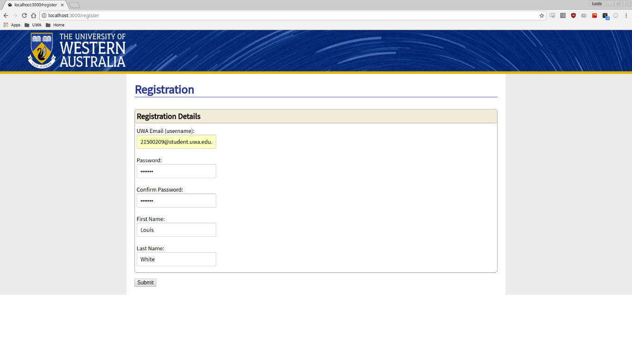

*Output:* 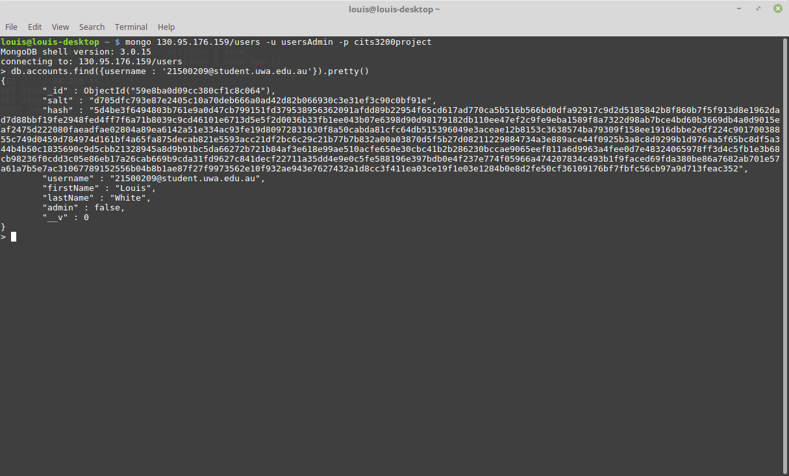

Secondly, Form 1 was tested.

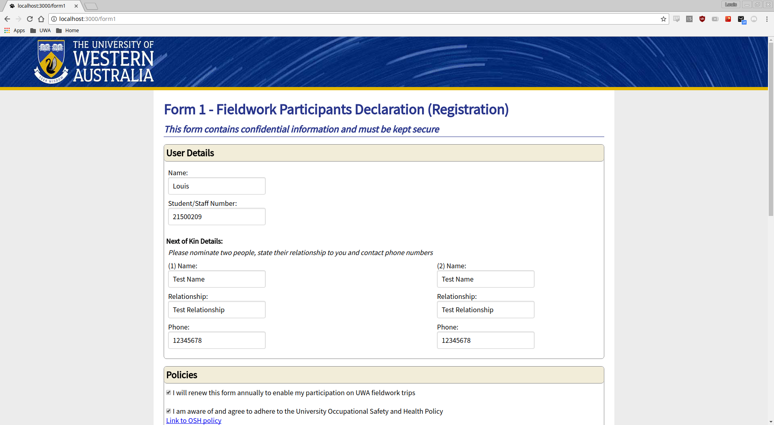*Input:*

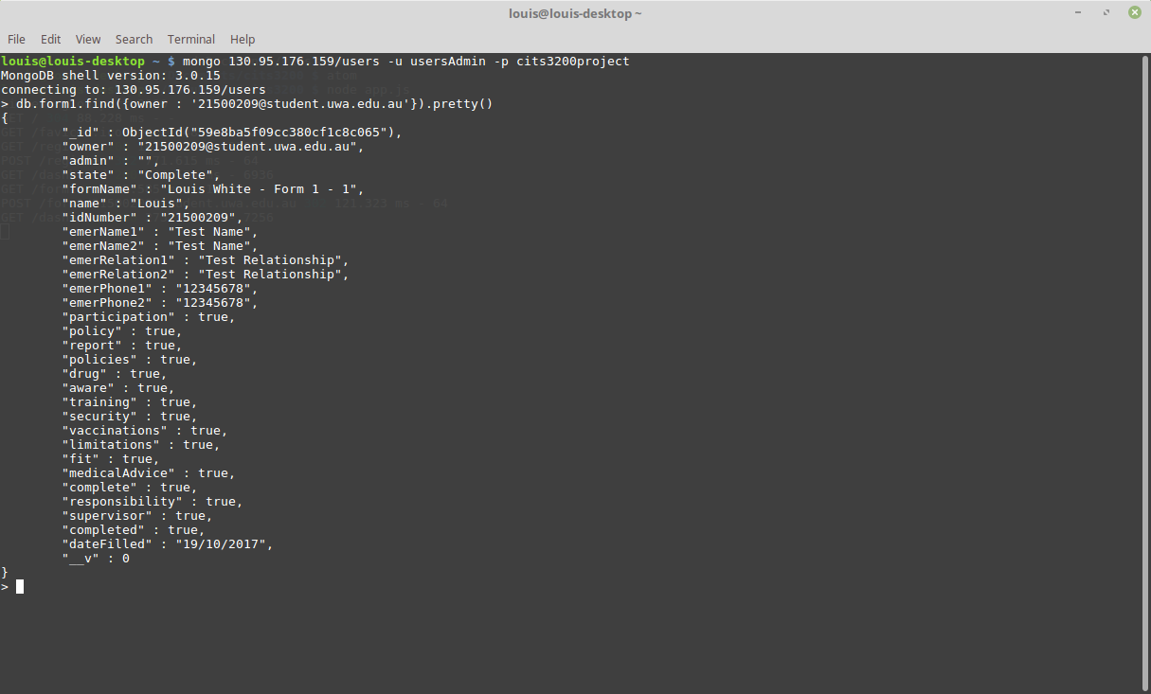*Output:*

Next, Form 7 was tested.

*Input:*

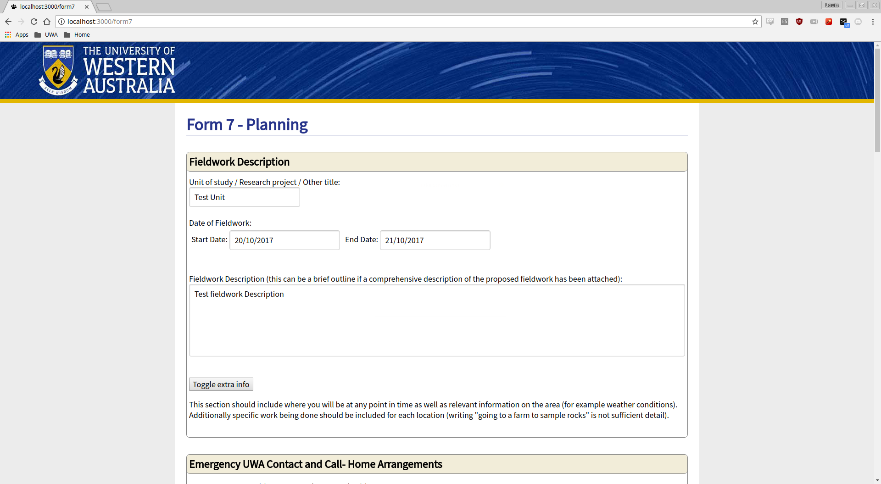

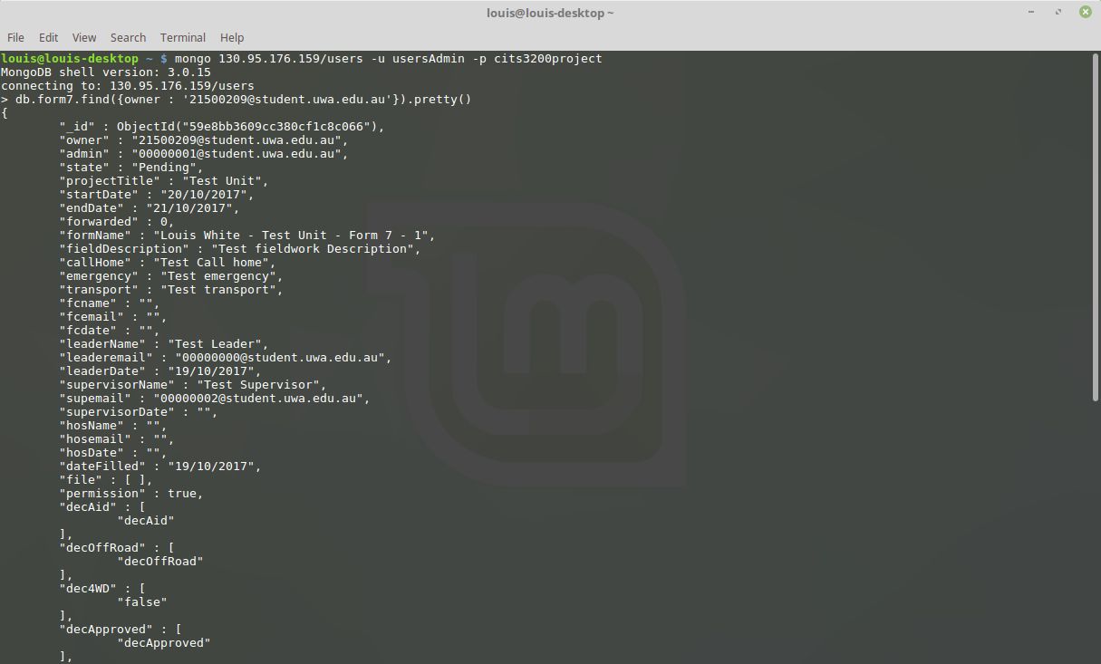*Output:*

Lastly, the Risk Assessment Form was tested.

*Input:*

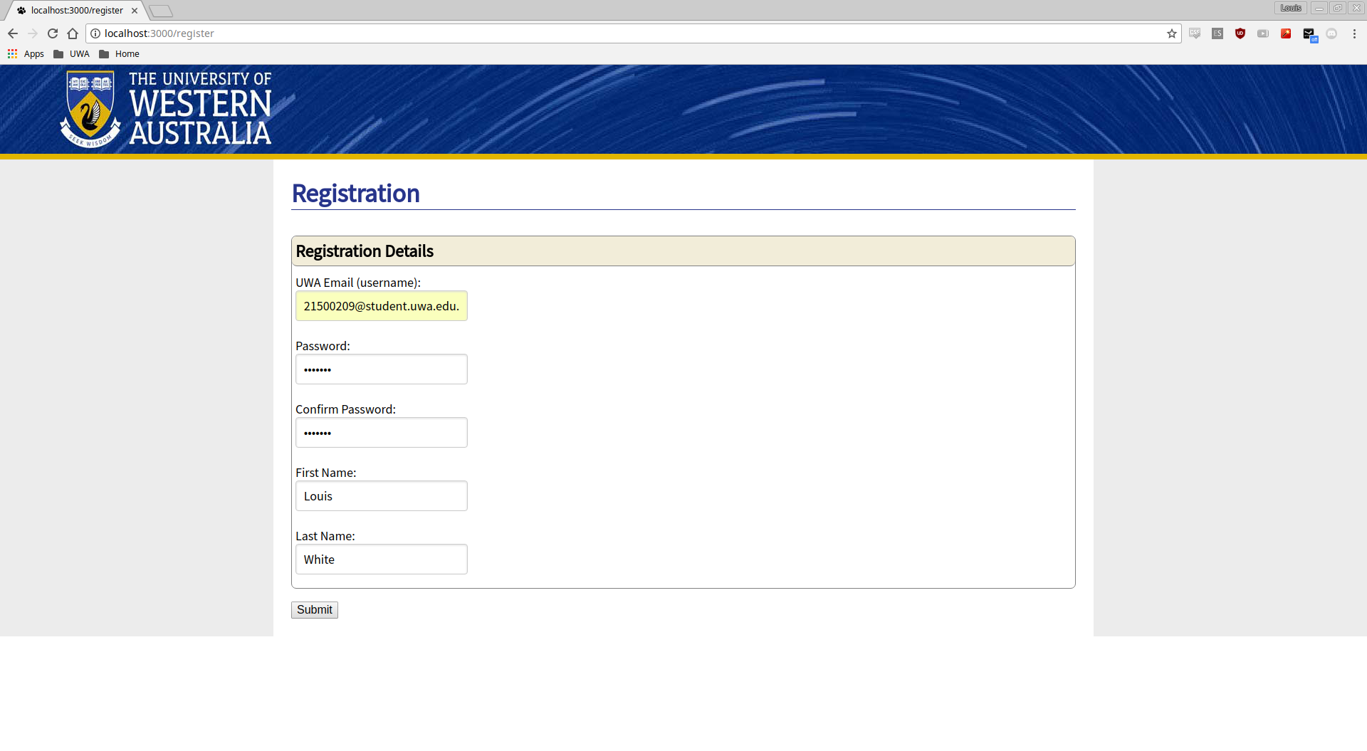

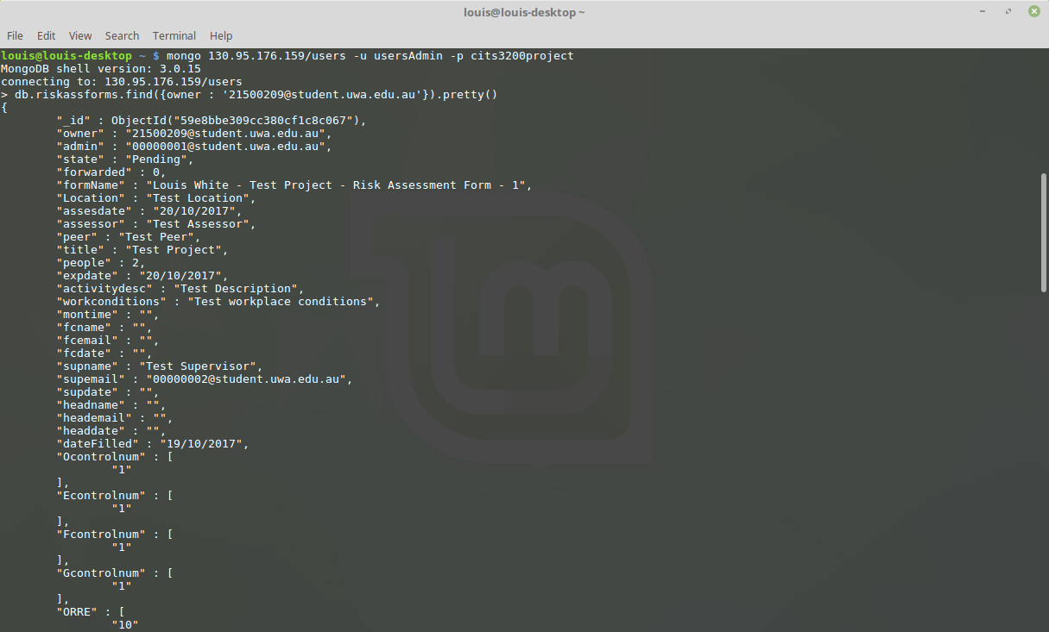*Output:*

As shown from the above screenshots, each piece of information is stored correctly in its respective fields.

**Test Case B**

The following test will test the number of concurrent users the system can handle at a single point in time. This test will also determine the number of users that can access the database at once. See Deliverable B Acceptance Tests document for more information.

**Expected Results**

The expected results for each test respectively:

* All users should be able to login with no errors whatsoever
* The system will take time to process each submission, but should be swift enough for practical use
* After submitting an application, users should not be able to edit them until an admin has either left the application reviewal page or sent the back for correction

**Testing Results**

When testing concurrent users, we deployed our code on Heroku and all logged in to separate accounts at the same time which was successful.

*Output:*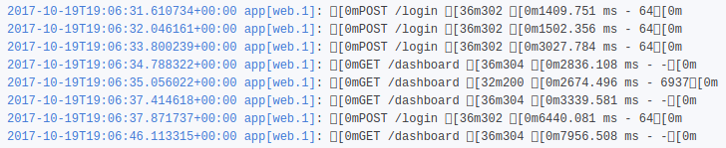

This test was also repeated by us all submitting form 1 at the same time, which was also successful.

*Output:* 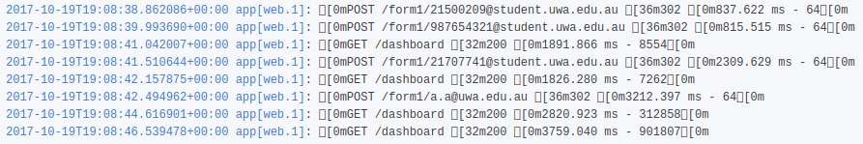

Testing was conducted on general loading of webpages and form submission.

*Output:* 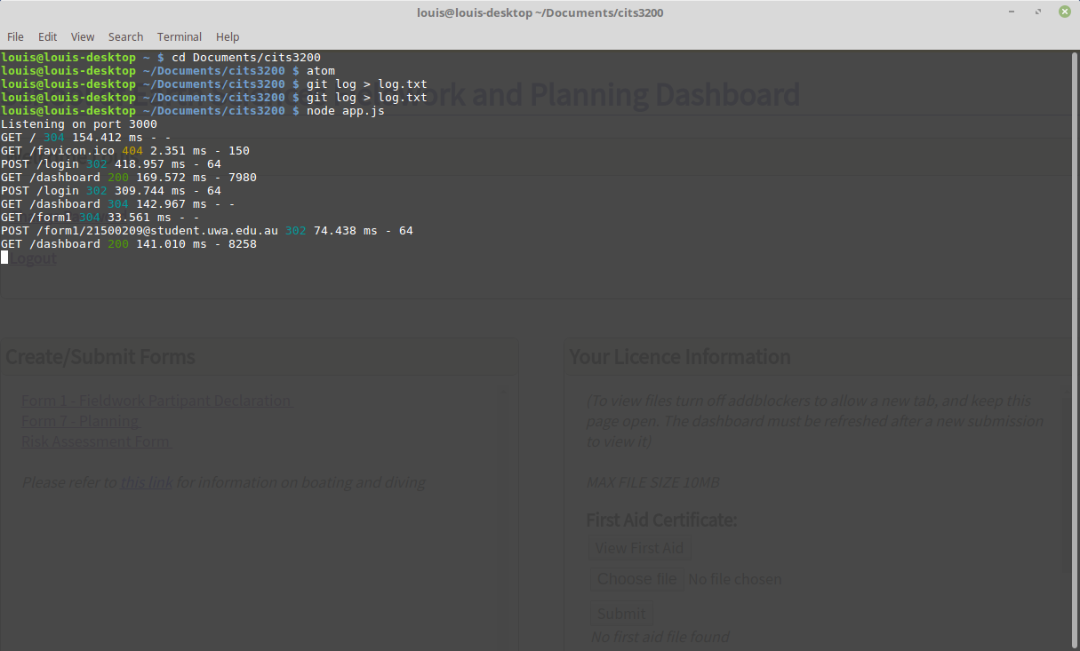

The database is queried and updated very quickly. Login was completed in 418ms and posting form 1 in 48ms.

When the user submits a form they can no longer edit the form that they have submitted. The screenshot below is taken after editing the form.

*Output:* 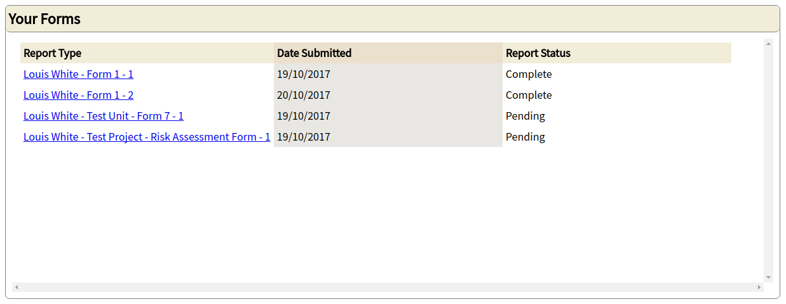

Users are unable to edit a form that has status completed or pending.

*Output:* 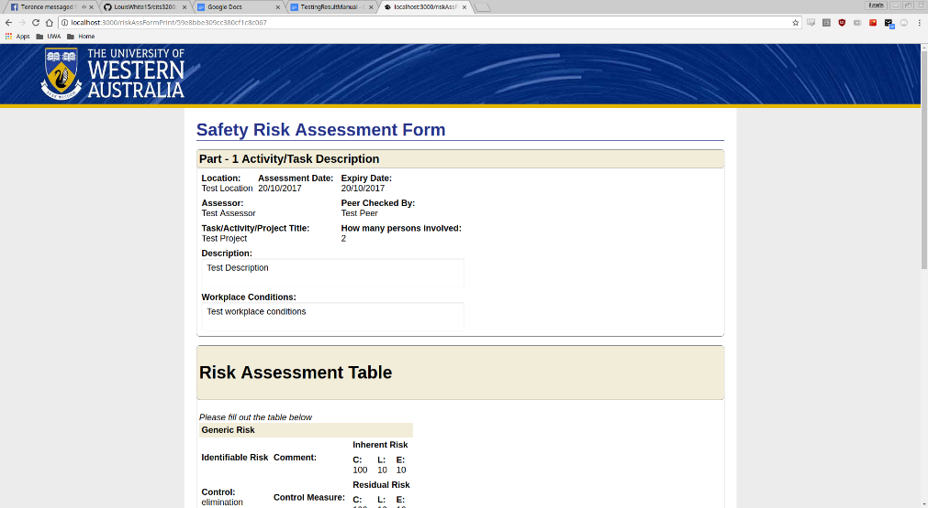

The report status on the dashboard is updated when a form is sent back for revision.

*Output:* 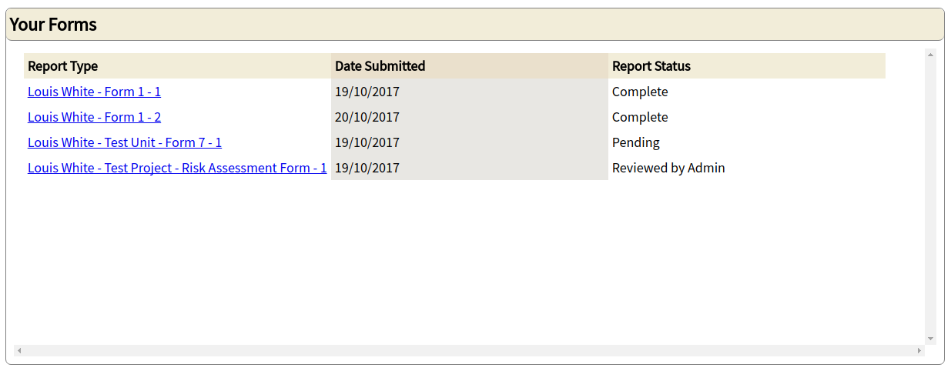

A form that has status reviewed by admin can be edited.

*Output:* 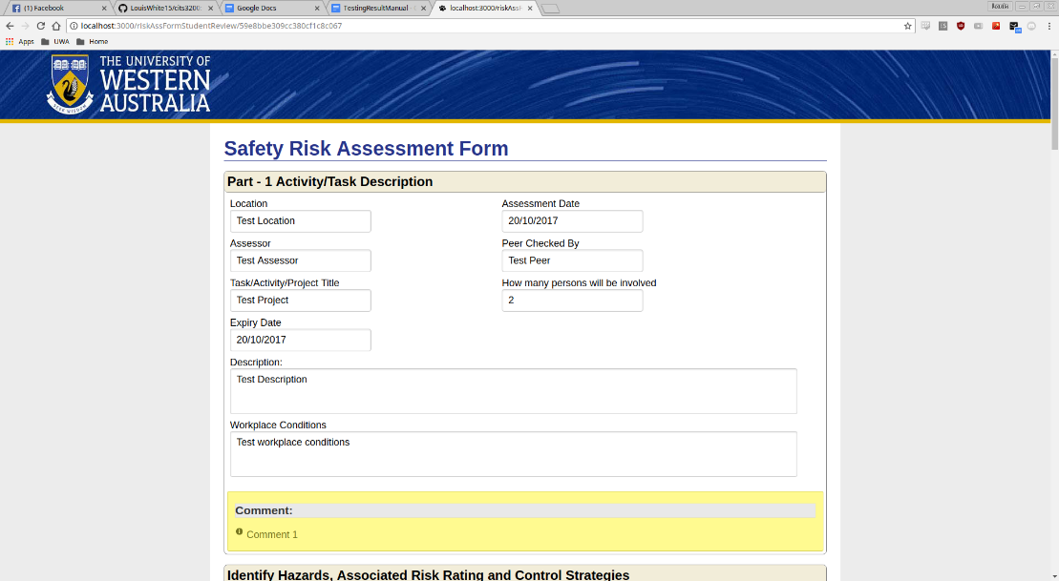

**Test Case C**

The following test is to ensure that sufficient error checking mechanisms are implemented to determine that applications are filled out correctly and completely. Additionally, the test will confirm that the correct responses to the submitted information is outputted by the system. See Deliverable B Acceptance Tests document for more information.

**Expected Results**

The expected results for each of the listed methods respectively:

* When filling out the application, there should be a word limit on each box that prevent users from overloading the application
* Each field should only allow for correct input format to be entered (eg. Numbers only in numeric fields)
* All numeric values in the risk assessment application should be displayed to users
* Applications should be prevented from submitting and create notifications if necessary fields are left blank
* A notification should be displayed if user is trying to access an application that has been submitted and is under review
* Users should be prevented from filling in applications when necessary information (eg. driver licence) is not provided

**Testing Results**

The following tests will show that each field will only allow the correct format.

*Input/Output:*  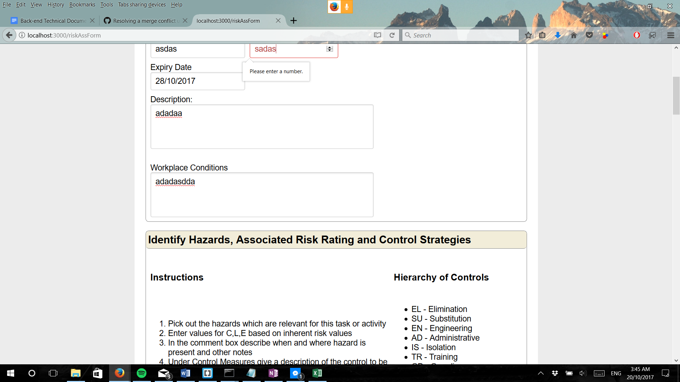

*Input/Output:*  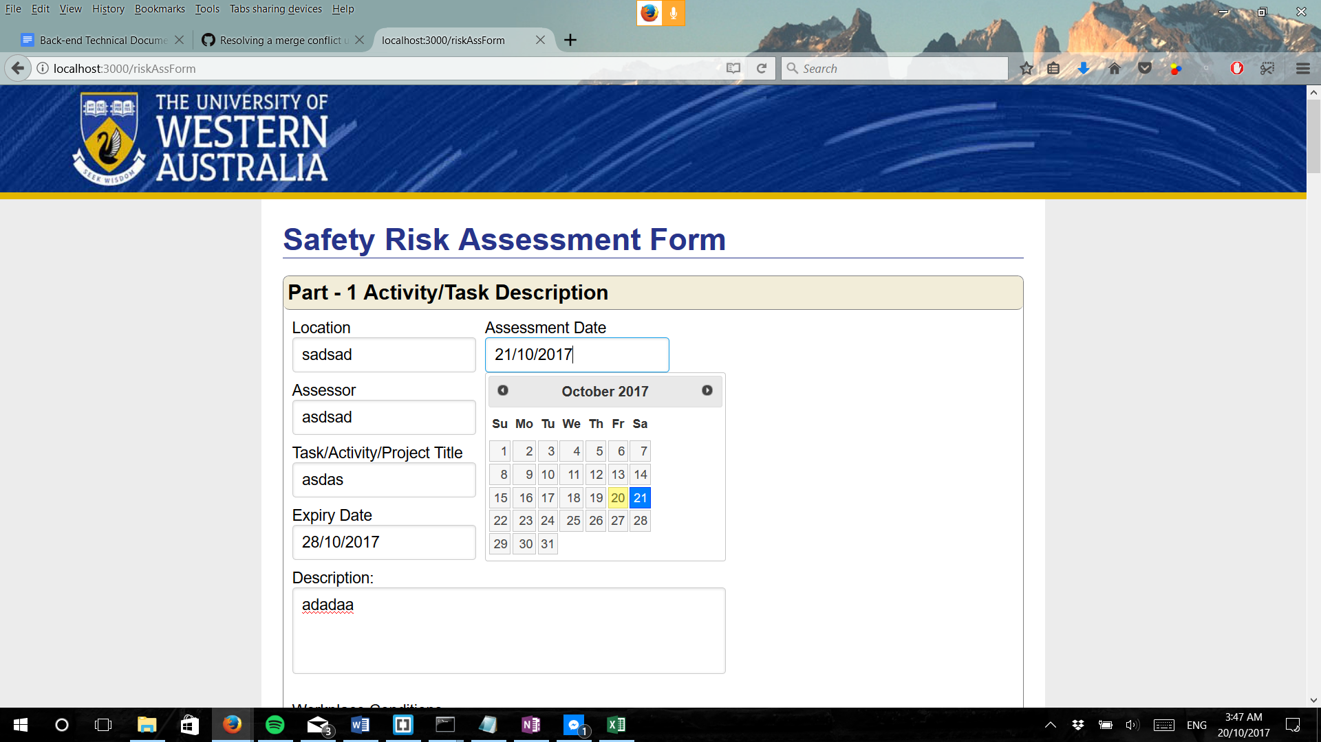

The result above was replicated in all 12 major date fields across all forms. This includes: start date, end date, itinerary date, fieldwork leader date, fieldwork supervisor date, fieldwork coordinator date and head of school date.

The following test shows that all numeric values in the risk assessment application should be displayed.

*Input/output:* 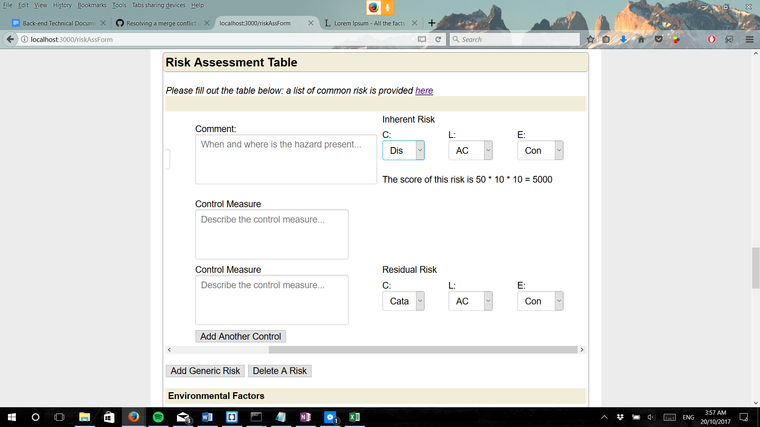

The above was replicated for all added risk across all risk assessment forms.

The following test shows that the system prevents a form submission and creates a notification if necessary fields are left blank. All necessary fields have a required tag.

*Input/Output:* 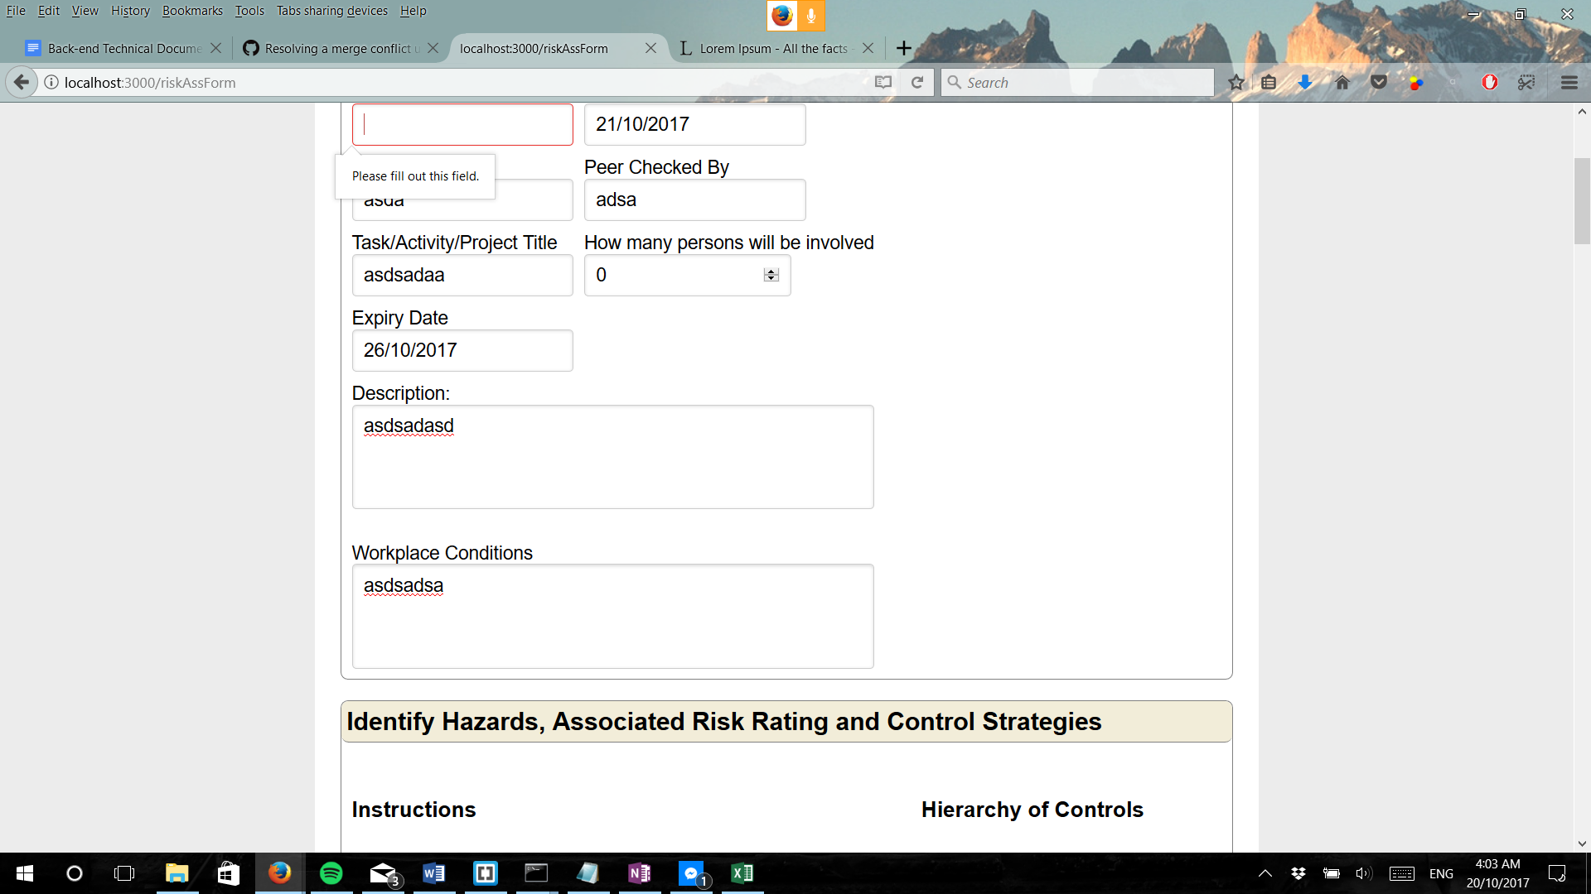

This was replicated across all forms. With the risk assessment form having 11 required tags, form 7 having 18 required tags and form 1 having 8 required tags.

The following test shows that users will be prevented from filling in forms when necessary information (eg. Form 1 completed) is not present. Form 7 and risk assessment form will not appear on the dashboard until form 1 is complete.

*Input/Output:*  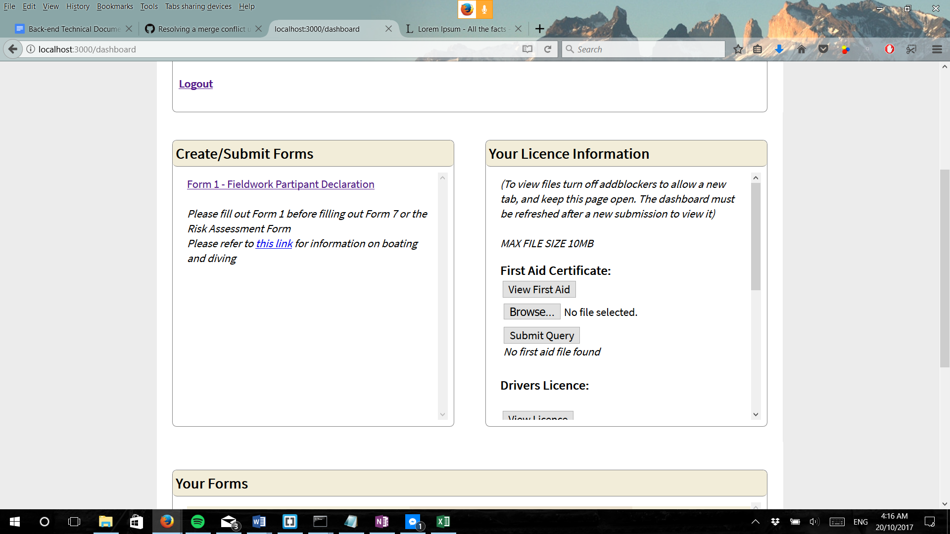

This is further reinforced by the fact that if form 1 is not complete, yet form 7 and risk assessment form is still on the dashboard, the two pages will not load.

*Input:* 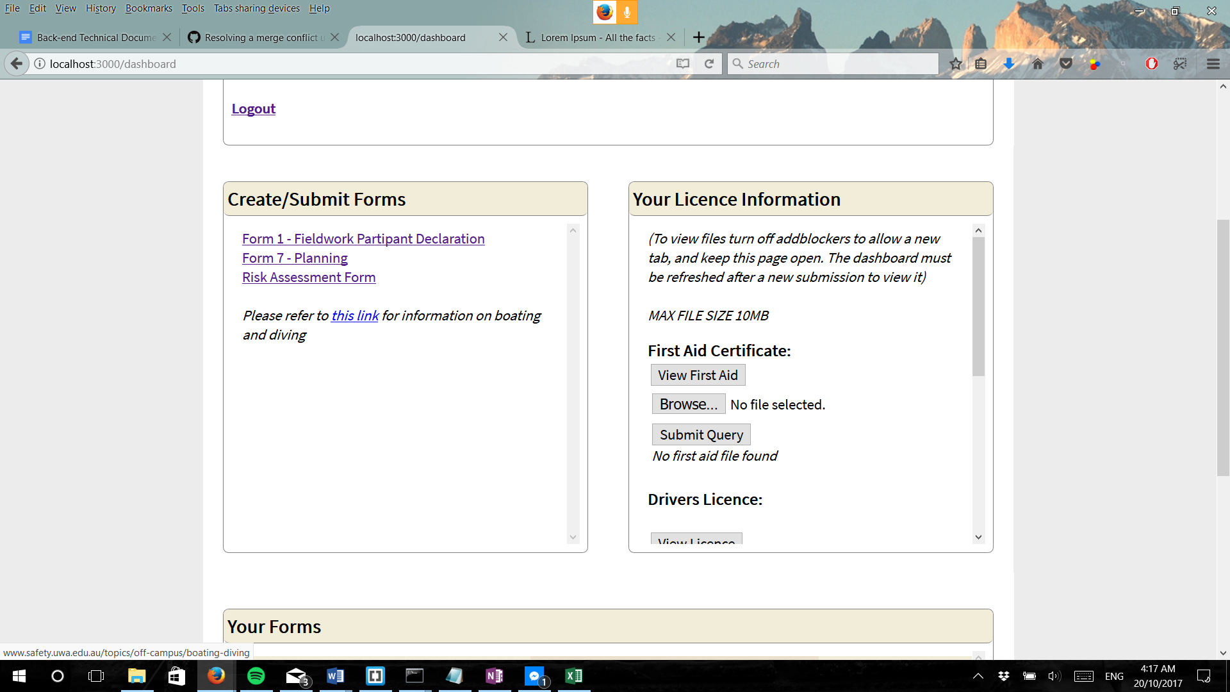

*Output:* 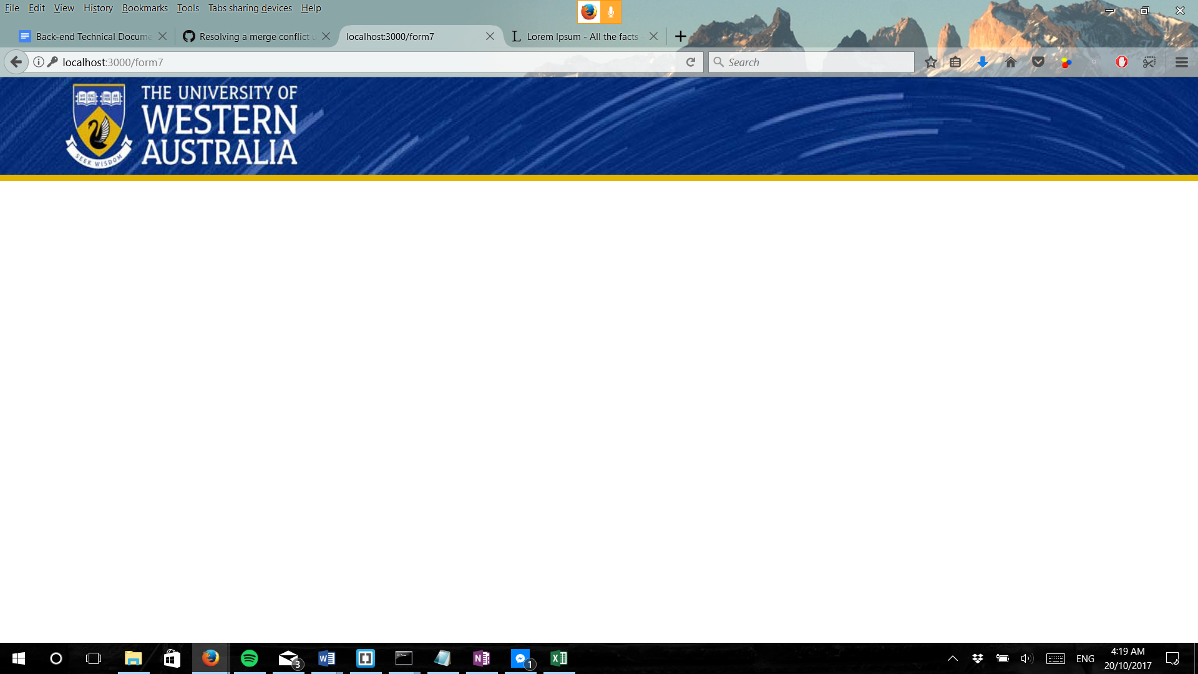

**Test Case D**

The following test will focus on user email and login to determine if the proper information and data is retrieved and presented to the user. This will also assess the accessibility of all user to personal information and ability to retrieve appropriate information regarding applications.

See Deliverable B Acceptance Tests document for more information.

**Expected Results**

Accounts will be created if the user’s email address is a UWA email address, otherwise a notification will be provided saying otherwise.

**Testing Results**

When creating an account with a valid UWA email address the data enters the database and the user is created and is ready to login and begin using the system.

The following test was conducted with an input of a valid student UWA email address. The output indicated that the data was correctly entered into the database, so the user can access the system.

*Input:* 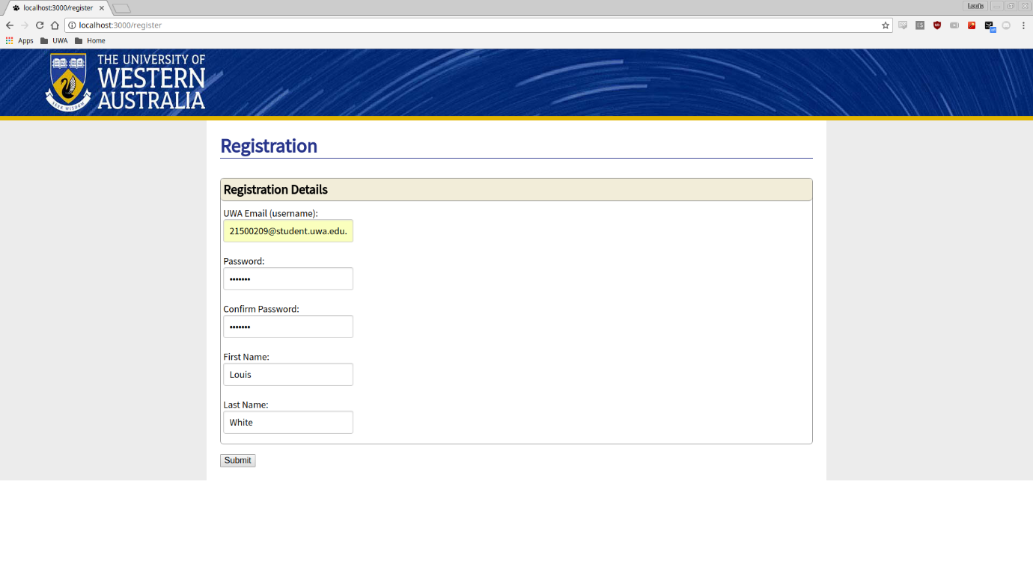

*Output:* 

The above test was repeated with a non- valid email address. An error message appears and the user is not allowed to register.

*Input/Output:* 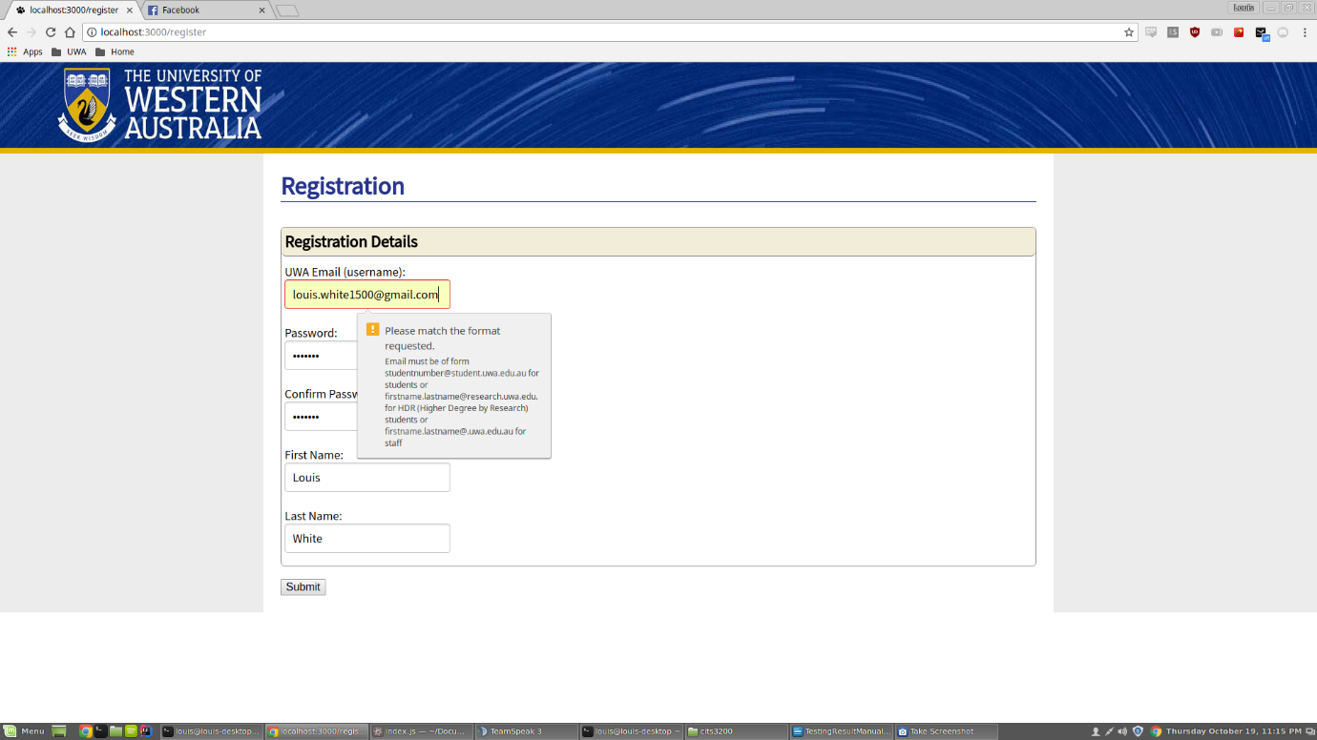

**Test Case E**

The following test will assess the ability of the system to convert applications to a format that is suitable for viewing and analysis, preferably PDF format as requested by client. See Deliverable B Acceptance Tests document for more information.

**Expected Results**

When users click the print button at the bottom of a document that has been submitted, a PDF version of the current HTML will be generated.

**Testing Results**

The following are results of a HTML to PDF conversion.

*Input:* 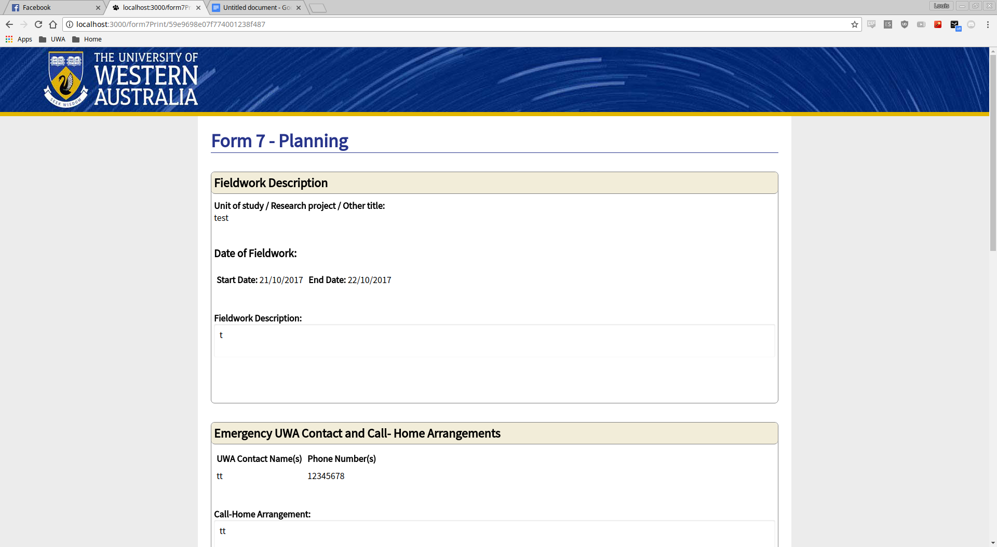

*Output:* 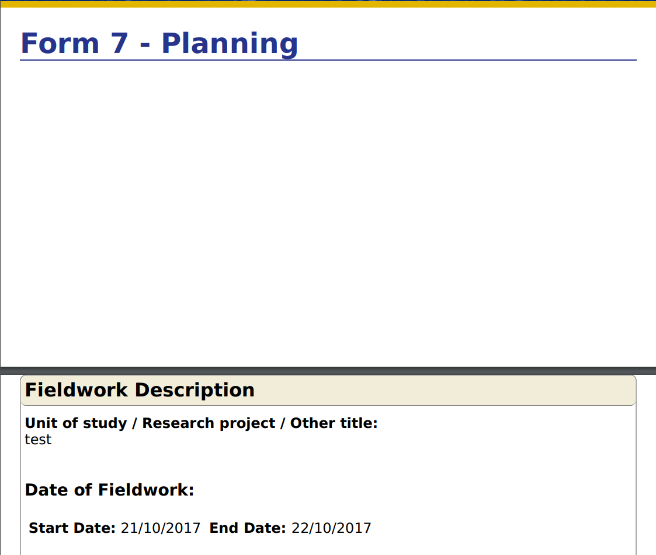

The PDF output formats information correctly by splitting it by sections. Note that the output above doesn’t show a full PDF.

**Test Case F**

The following test focuses heavily on the usability and accessibility of the system as a whole. Each feature of the system will be tested to determine its reliability, ease of use and presentation for all users. See Deliverable B Acceptance Tests document for more information.

**Expected Results**

With regular resolution (1920x1080) and full sized window, the page layout should be neat and uncluttered. Outlined sections or boxes should not be touching, there should be no overflow of content and if there is a scroll bar should appear giving you access or view of all content on a page. Auto expanding textboxes should only expand vertically and should not interfere with the styling of the rest of the page. The styling across pages should be consistent.

When page is resized (in this case shrunk from full screen) the styling should not change until elements cannot be seen on the page without adjustments. In this case elements like text boxes should group together as much as possible in attempt to display them all on the screen. Scroll bars should appear for the window which let you navigate the whole form even if the window size has been reduced. At all times text sizes should be readable. The adjustment in page layout should not lead to any items being covered or inaccessible (for example two buttons overlap). The above tests will be repeated on lower and higher resolution in order to ensure the system is still working as intended. All tests and features performs identically across browsers.

**Testing Results**

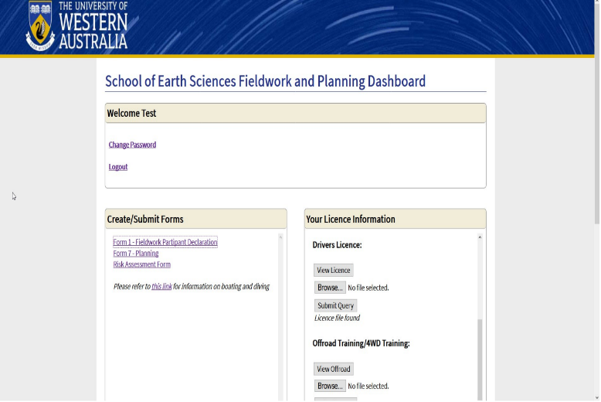Benchmark resolution (1920x1080, full-width):

*Dashboard:*

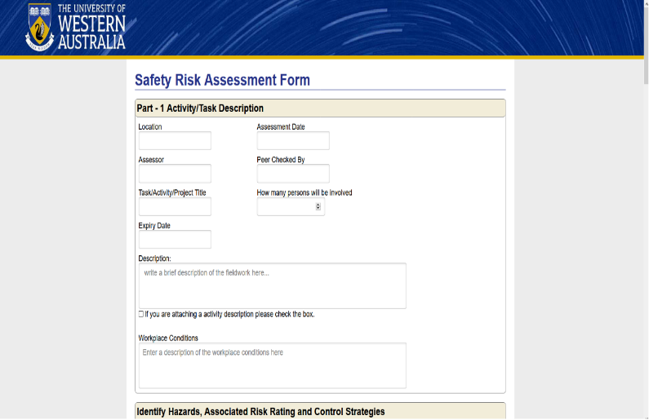*Safety Risk Assessment Form:*

1920x1080, half-width:

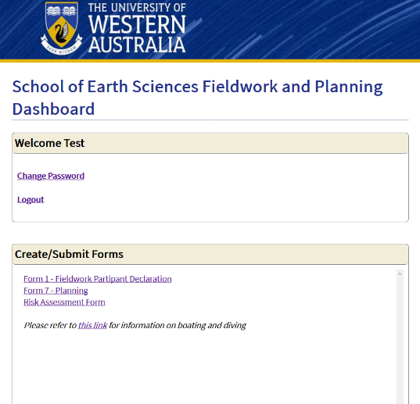*Dashboard:*

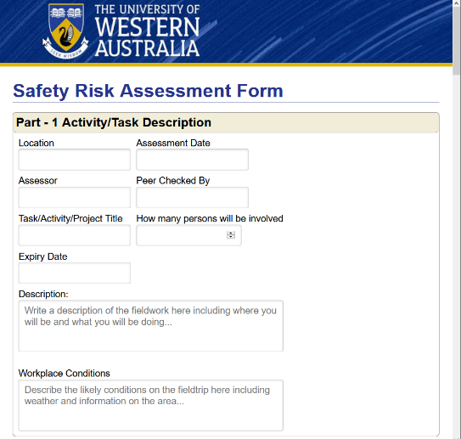*Safety Risk Assessment Form:*

1280x720, full-width

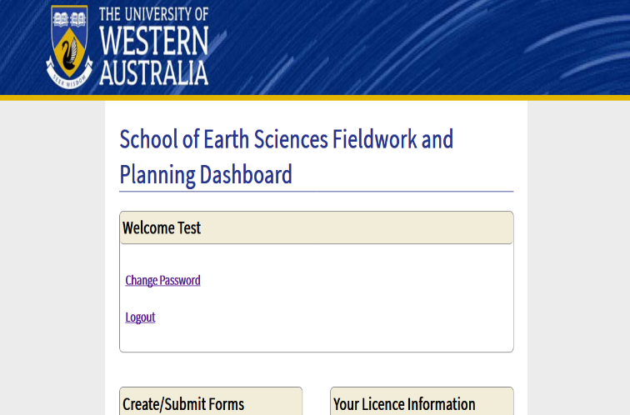*Dashboard:*

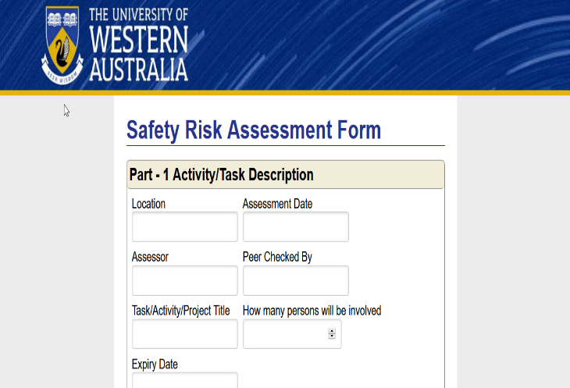*Risk Assessment Form:*

1280x720, half-width

*Dashboard:*

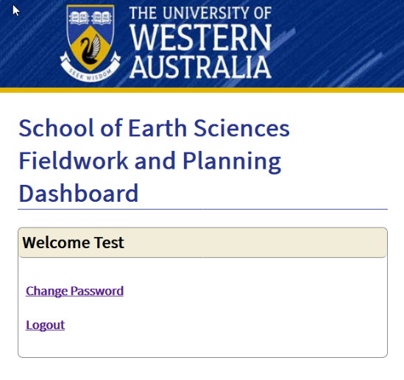

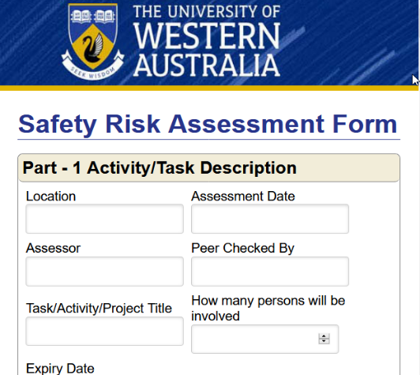*Risk Assessment Form:*

Fully Functional **|** Functional but buggy (refer to final row) **|** Broken

|  |  |  |  |  |  |
| --- | --- | --- | --- | --- | --- |
| **Tests** | **Browser** | | | | |
| Opera | Firefox | Chrome (Win and Mac) | Internet Explorer | Microsoft Edge |
| User Registration |  |  |  |  |  |
| Form filling |  |  |  |  |  |
| Form printing |  |  |  |  |  |
| Admin access |  |  |  |  |  |
| Change password |  |  |  |  |  |
| Styling |  |  |  |  |  |
| **BUGS FOUND** | Form printing requires a modification of Opera settings |  | Form printing requires a modification of Chrome settings |  |  |

*Firefox:* 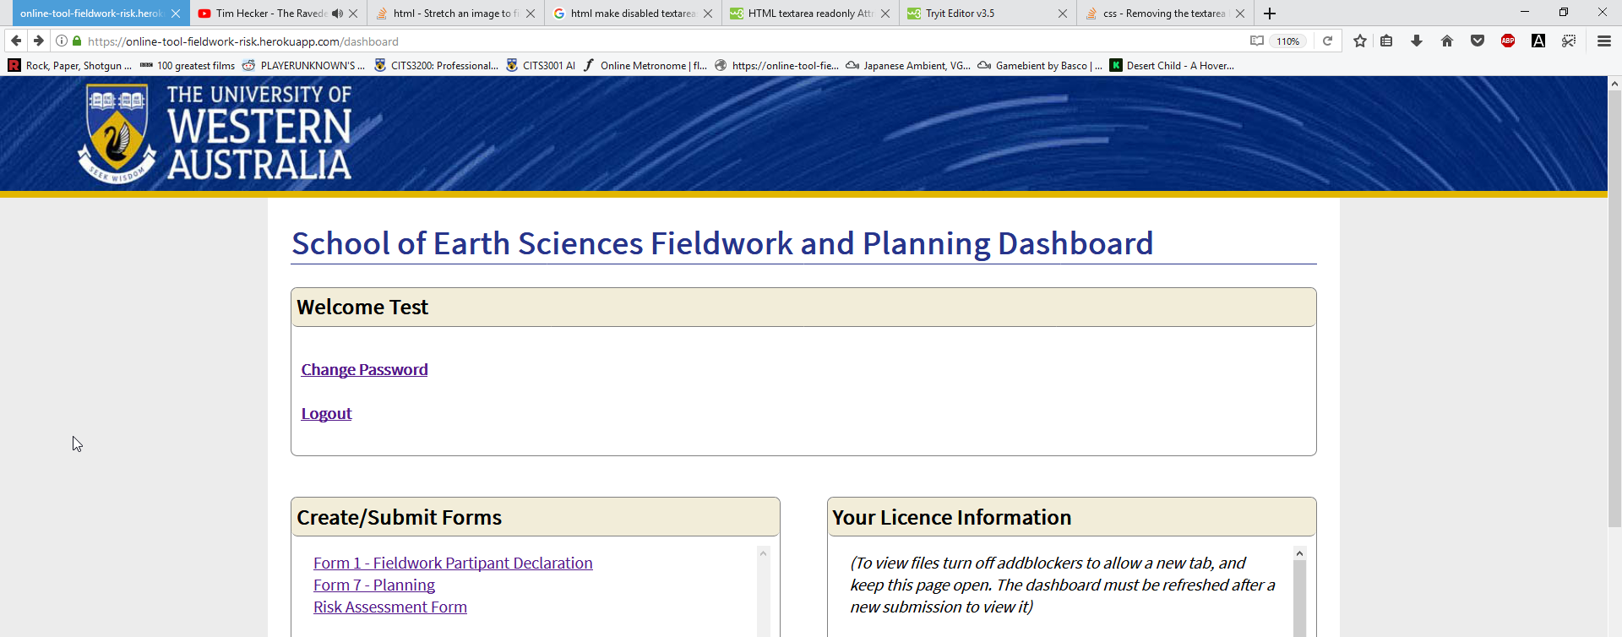

*Internet Explorer: 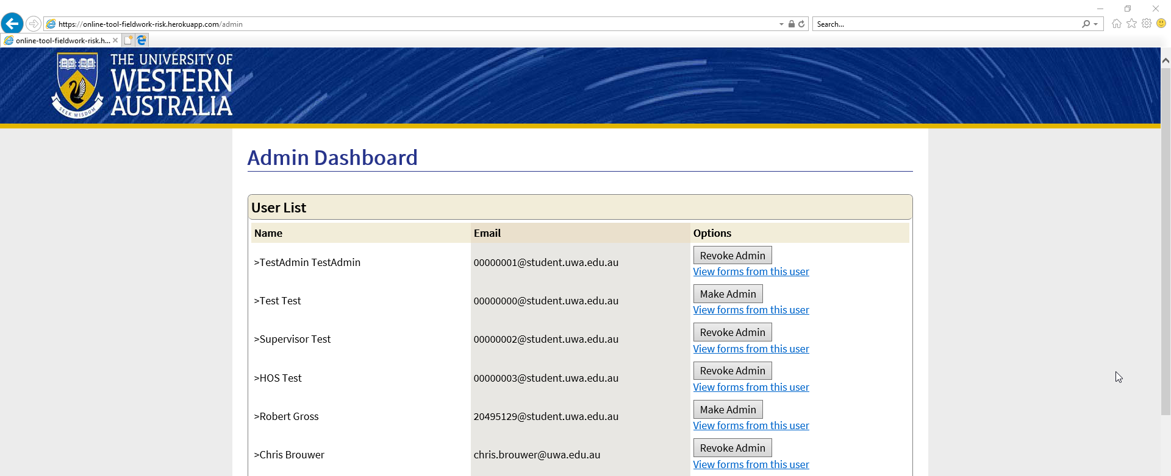*

*Chrome:*  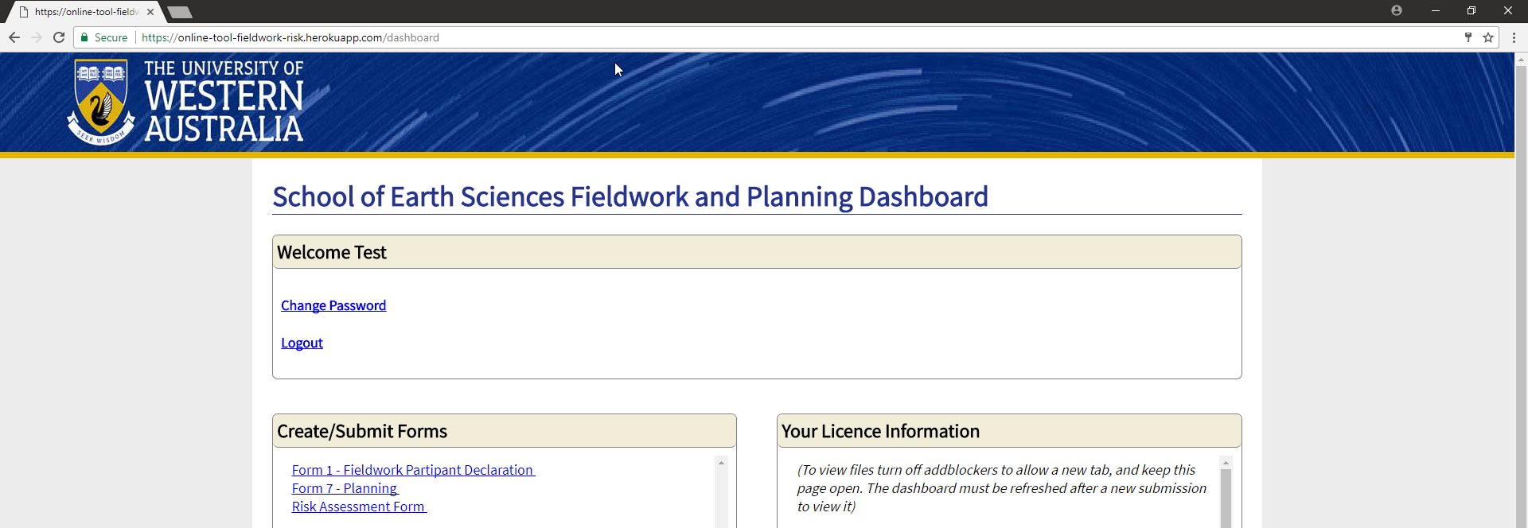

*Opera:*  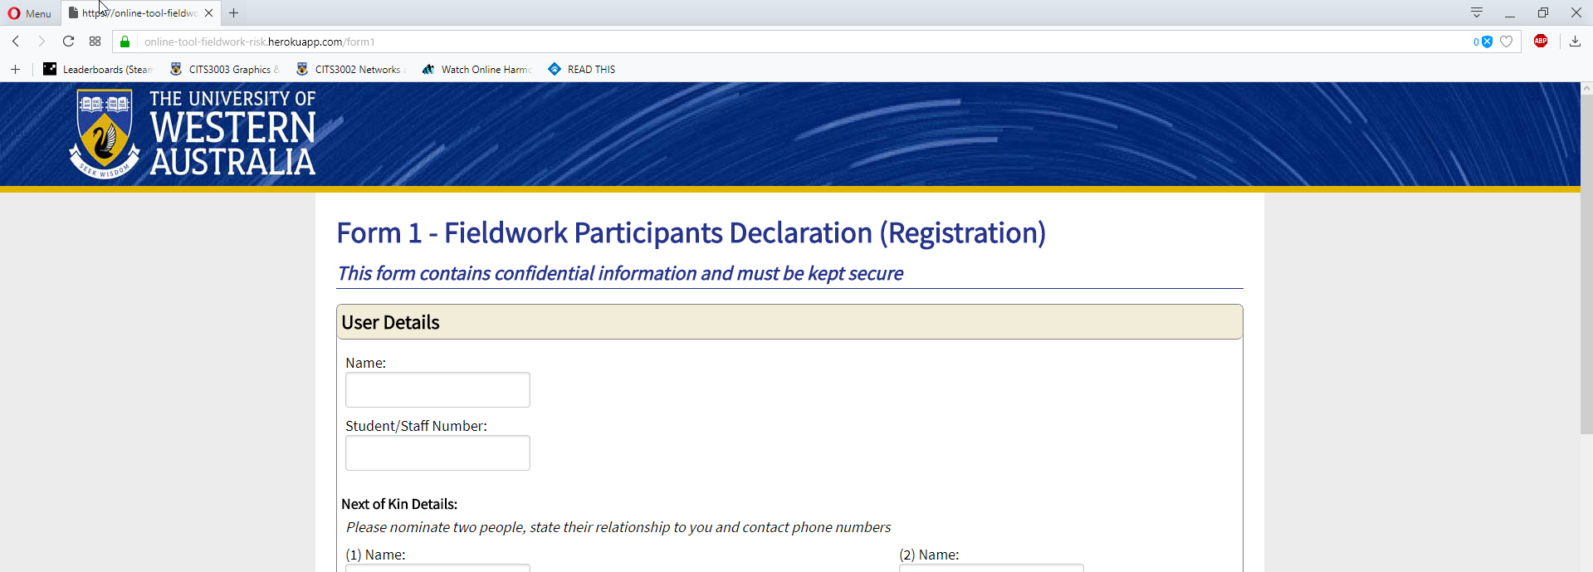

*Edge:*  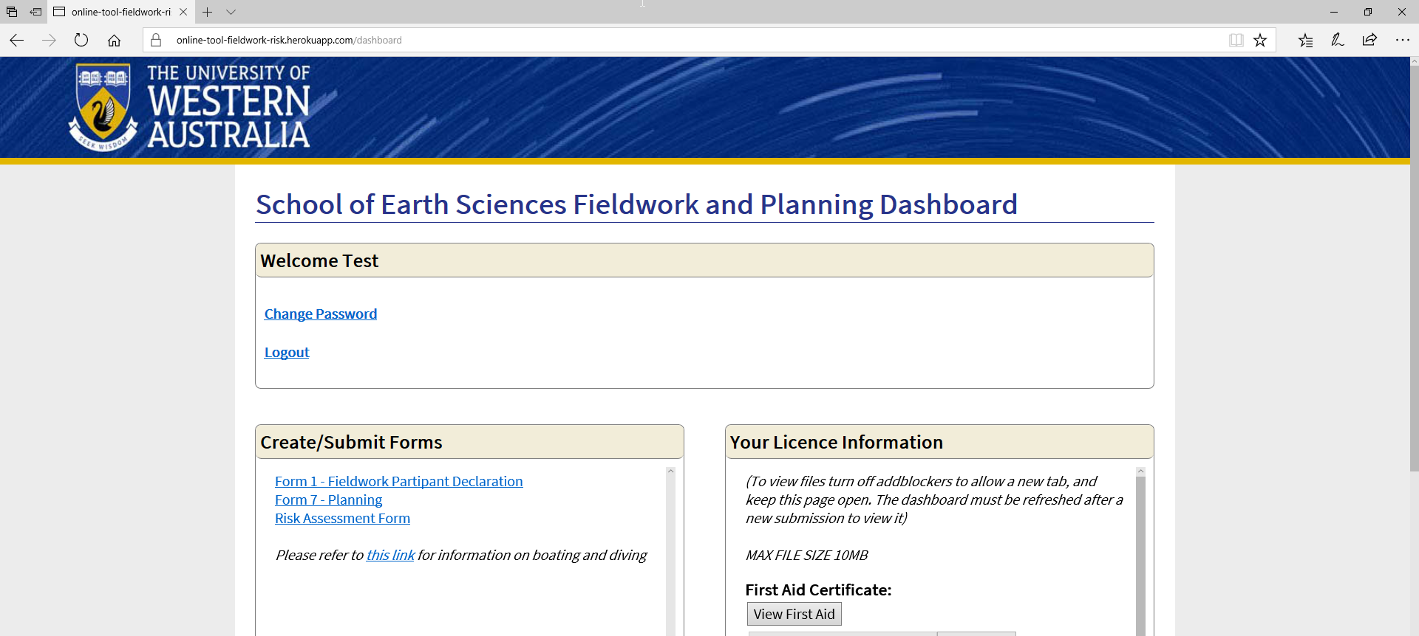

**Test Case G**

This tested was to ensure that if values were entered into a form, they would then display correctly across the review form, student review form and print form for that document. These values were then updated for the other forms such as review, student review and print. This was repeated for the three major types of forms that we had form1, form7 and risk assessment form.

For this test, a dummy form was created so that the values in each form could be checked on the form to ensure they had displayed correctly. The format of this test was to have the dummy form mirror the description of the field so that it was easy to check that the output on another form was correct. E.g. if the fields title was location then the value entered would be location. This was repeated for all inputs. In the case of dynamic fields, a certain number of fields were added, and then numbered off. E.g. contact name 1, contact name 2.

**Expected Results**

The expected results for a particular form would be as follow:

* Once a user has filled out a form successfully, whatever values that user has entered are then successfully viewed in the review form.
* Any changes that are made within the review form are updated and successfully displayed within both the student review and review forms.
* When a student makes a change in the student review form and submits those changes they are updated in the review.
* The print form should also show the current state of the form at all times.

**Testing Results**

The following is an example of a dummy form that is entered into the database. Note that all forms were filled out in this manner to ensure that it was easy to view the final results. These were then checked to see that they successfully displayed in form review.

*Input:*  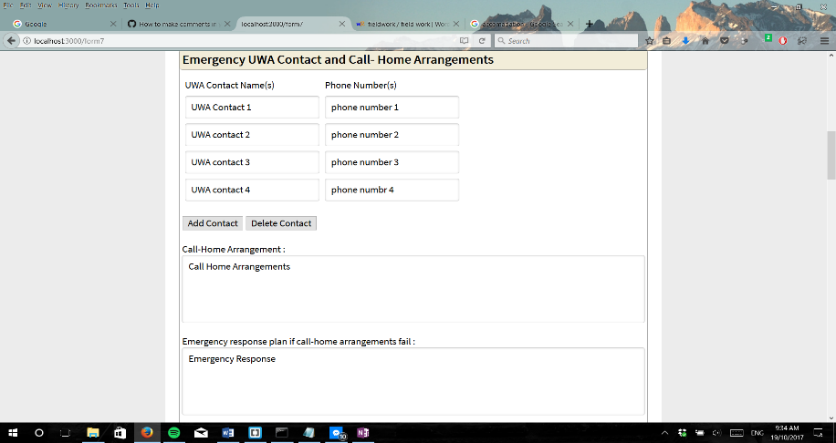

*Output:* 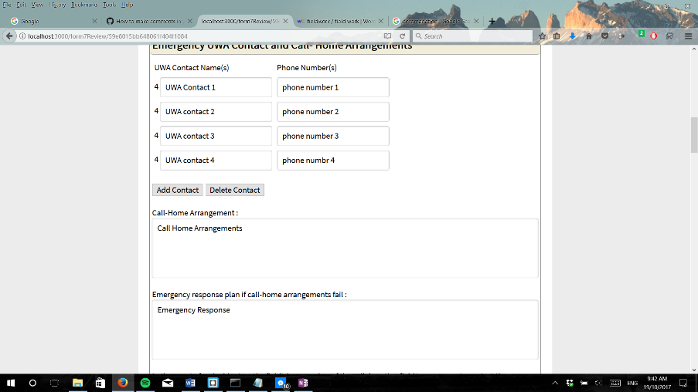

Values were then updated within the review form. These values were then submitted and checked in the student review form.

*Input:* 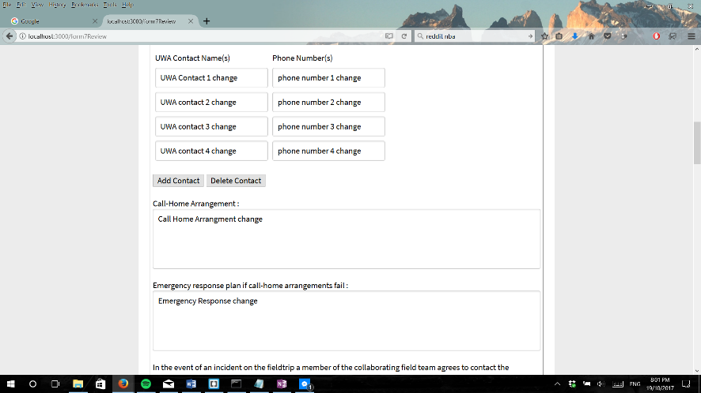

*Output:* 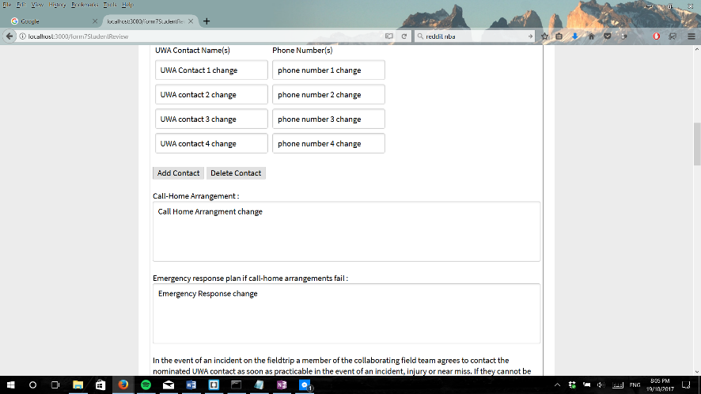

Values were then changed in the student review form. These values were then submitted and checked in the review form. These were also checked in the review form.

*Input:* 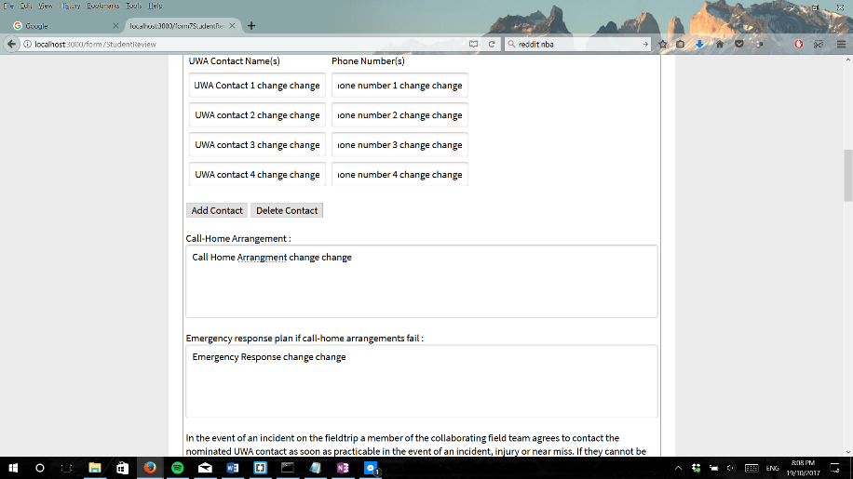

*Output:* 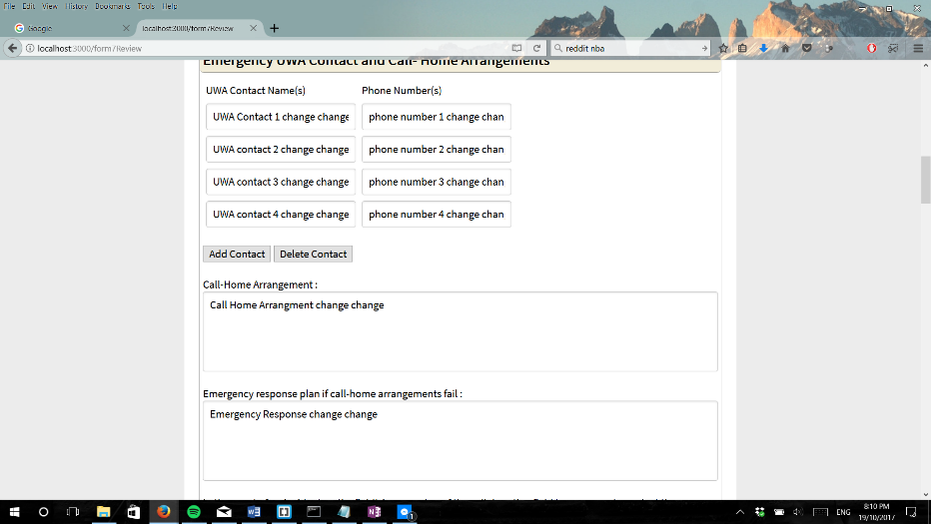

*Output:* 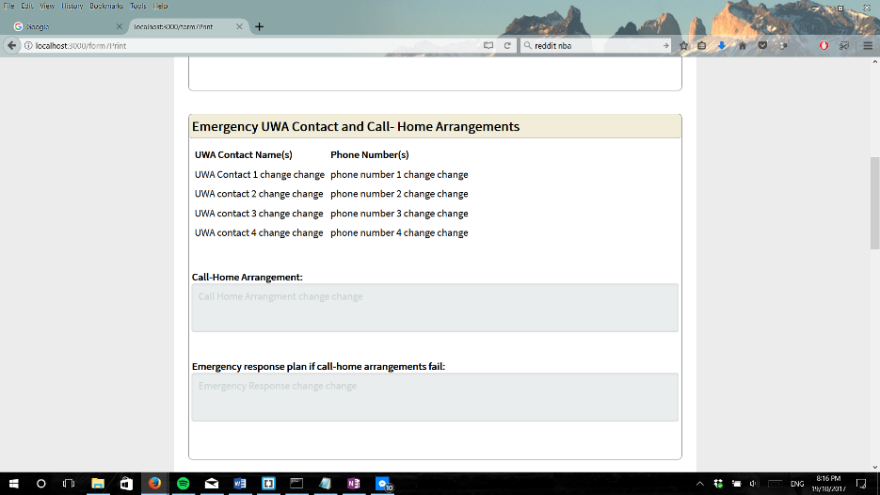

This process was repeated for all forms and was successful. All field displayed correct values in each instance that was checked.

**Test Case H**

The aim of this test was to ensure that when an admin or a student adds a new field dynamically after they have submitted their first form that they are able to add that field dynamically a second time. It also test that when they fill in values and submit, this new value is displayed correctly in all other forms. Finally, it test when a user wants to delete a value they are able to do so and when deleted, this is reflected in all other forms when submitted.

To test this a dummy form with lorem ipsum was first generated. This form was then looked at in the review section where dynamic values were then added to the form and submitted. This was then viewed in the student review form to ensure that the value are displayed correctly. This process was repeated in reverse, adding in student review and submitting then viewing in review. After this the deletes on forms were checked. Previously added fields were deleted in the review form to test this. The updated form is now submitted and viewed in student review. This process was then repeated in reverse as well.

**Expected Results**

The expected results are as follow:

* Admin can successfully add dynamic fields in all places where there is an option to. When submitted, these values will then successfully be displayed across forms.
* User are able to delete all dynamic fields in all places where there is an option to. When submitted, these values will then successfully be displayed across forms.

**Testing Results**

A dummy form was created and submitted with lorem ipsum and is simply used as a starting point to dynamically add forms in. Within the review form, the fields were dynamically added in all places where it was available. This was then checked in the student review form.

*Input:* 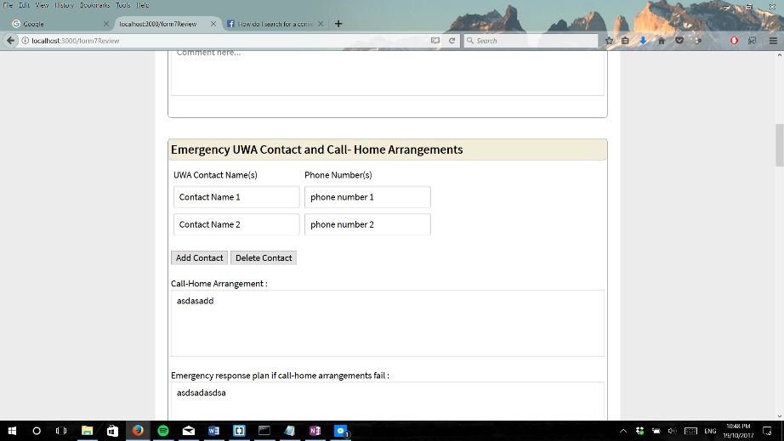

*Input:* 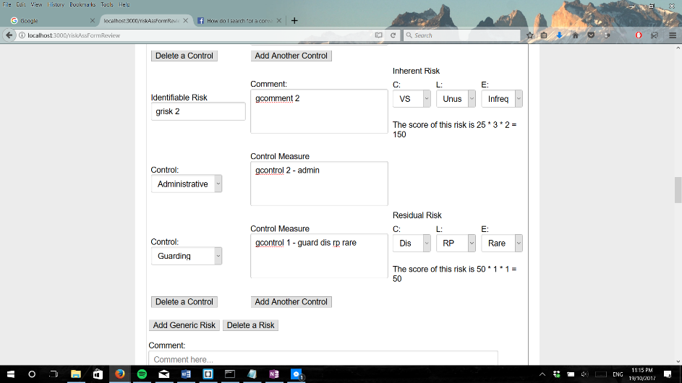

*Output:* 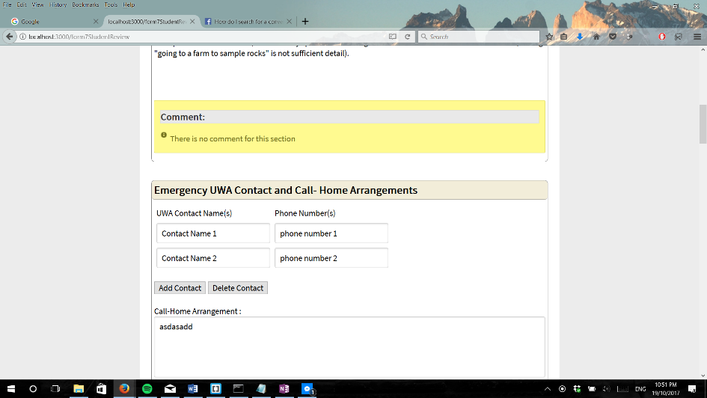

*Output:* 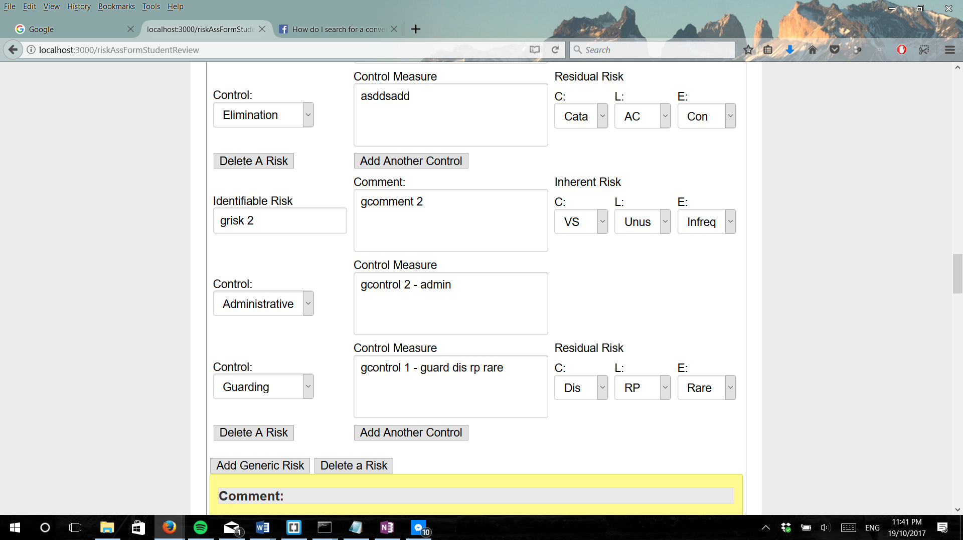

This was repeated and was successful. These were then checked within the review form.

*Output:* 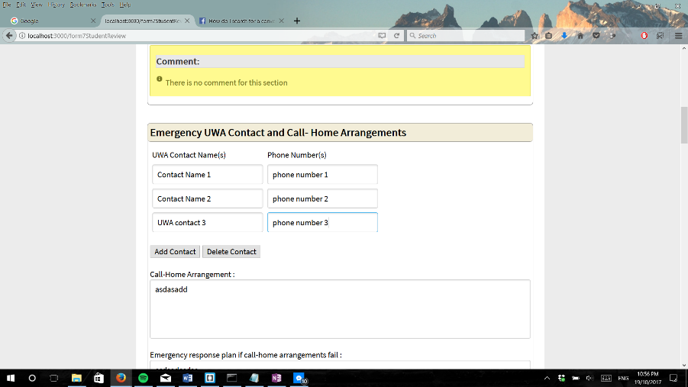

*Output:* 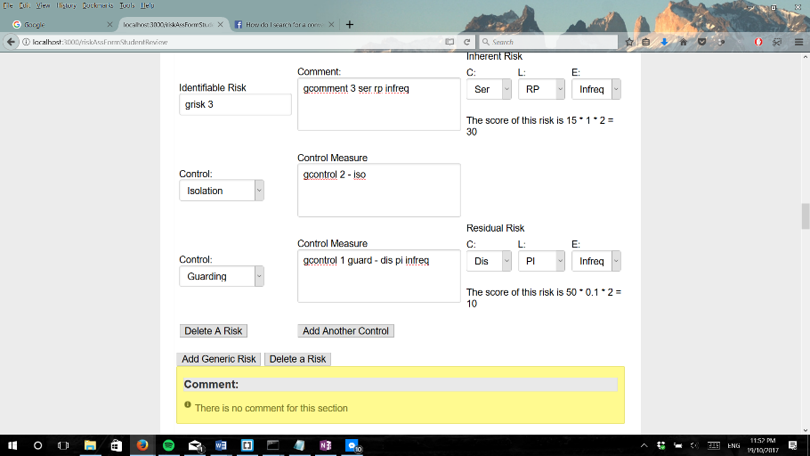

*Output:* 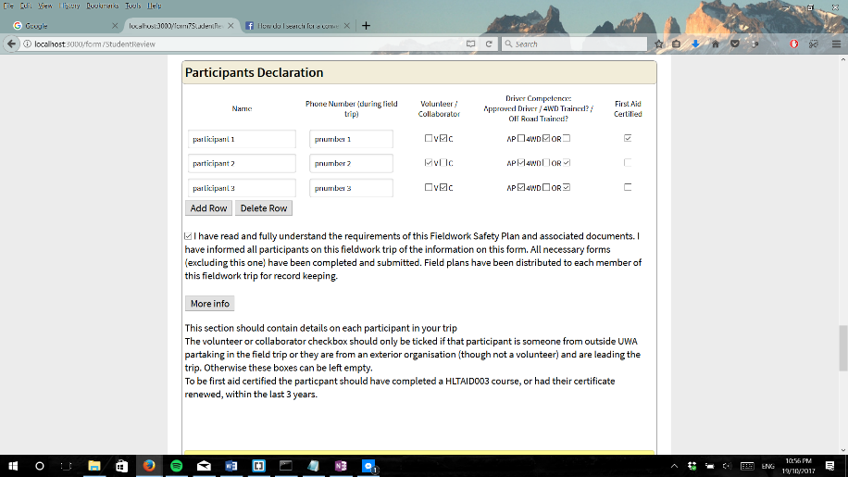

*Output:* 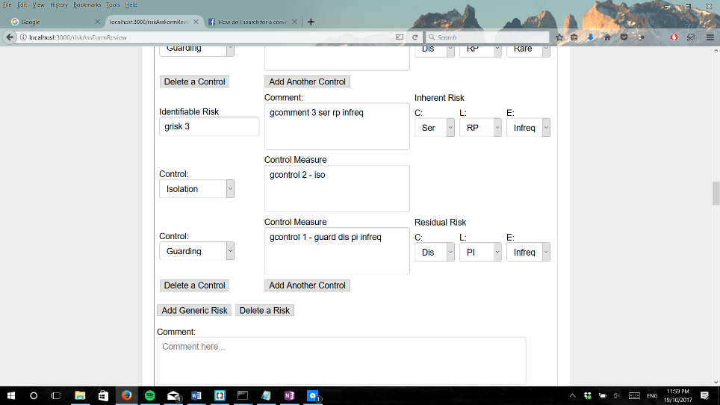

This concludes the testing of adding dynamic fields. The following results are for testing of deleting dynamic fields. This was then checked in the student review form.

*Input:* 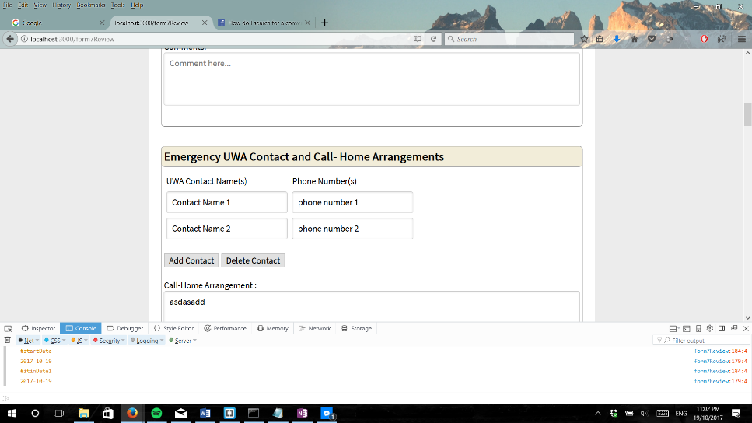

*Output:* 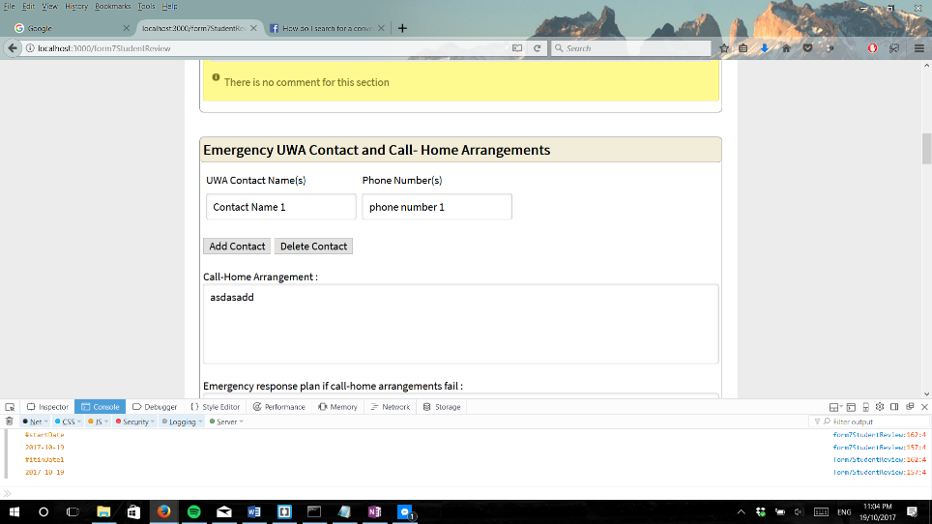

This was repeated and was successful. These were then checked within the review form.

*Output:* 

*Output:* 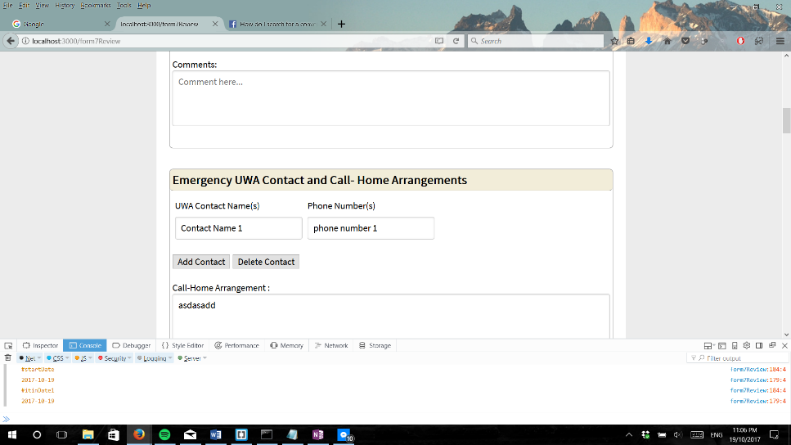

All above test reflected the expected results with an exception to the delete function in the risk assessment form. The delete function for control was not implemented to work after a new risk has been added.

**Test Case I**

The aim of this test is to ensure that users are able to upload PDF and view the PDF that they have uploaded. This will be conducted by uploading a random PDF into the database.

**Expected Results**

The expected results are as follow:

* When a PDF file is chosen and submitted, it’ll be successfully inserted into the database
* When the view button is clicked, user will be able to retrieve and view the uploaded PDF

**Testing Results**

The following are the results collected after uploading a PDF to the First Aid Certificate option on the dashboard. When the view button is clicked, the PDF will be retrieved and displayed in a different tab.

*Output:*  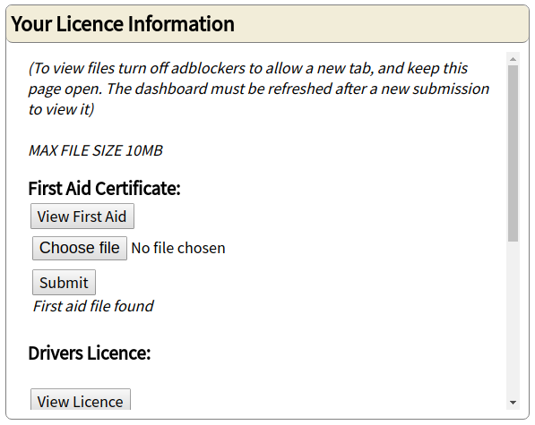

*Output:* 